INSTALLING MONGODB:

-To install MongoDB on Windows, download the latest release of MongoDB from <http://www.mongodb.org/downloads> and complete all the installation process.

-In the explorer, go to C>program Files>MongoDB>server>5.0>bin

-Now open command prompt and paste the path of above folder, i.e.,

cd C:\program Files\MongoDB\server\5.0\bin

_Type mongo.exe and then click enter.

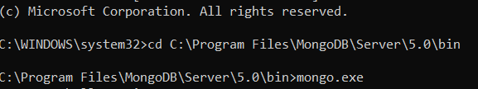

Inserting of the documents:

db.student insert({“name”:”renuu”})

C

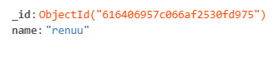

db.student.insert(

…{

…name:”abc”, age:”25”,address:{city:”kochi”,state:”kerala”,}})



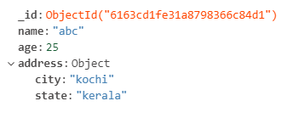

Checking inserted documents: find()

Creating array of documents:

-For this, pass an array of documents to the db.collection.insert()method.

-After doing this, pass Allcourses array to the db.collection.insert()method to perform a bulk insert.

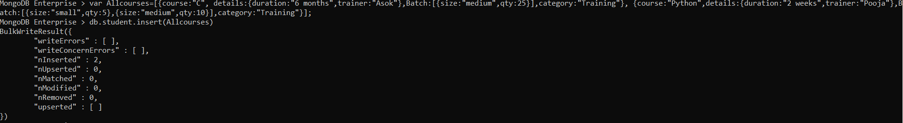

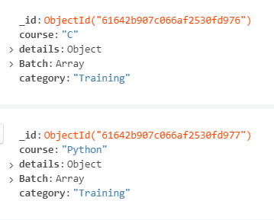

Update documents:

db.collection_name.update(selection_criteria,updated data)



Delete documents:

Db.collection_name.remove(deletion criteria)

Eg: db.student.remove({})

Aggregations:

Groups the value from several documents and does many operations here and a final result is obtained.

>$group : Allows us to perform operations across all grouped documents.

>$sum : Sums a field in all of the documents in a collection.

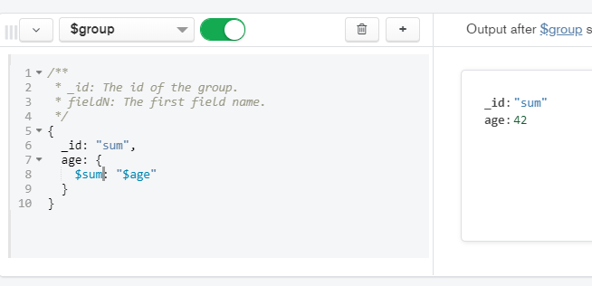

>$match : Reduces amount of documents which is given as the inputs to the succeeding stages.

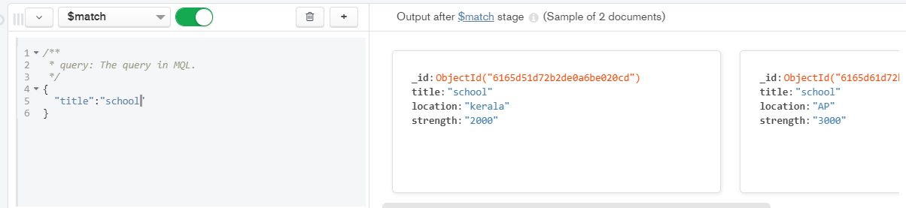

>$avg , $max, $min: